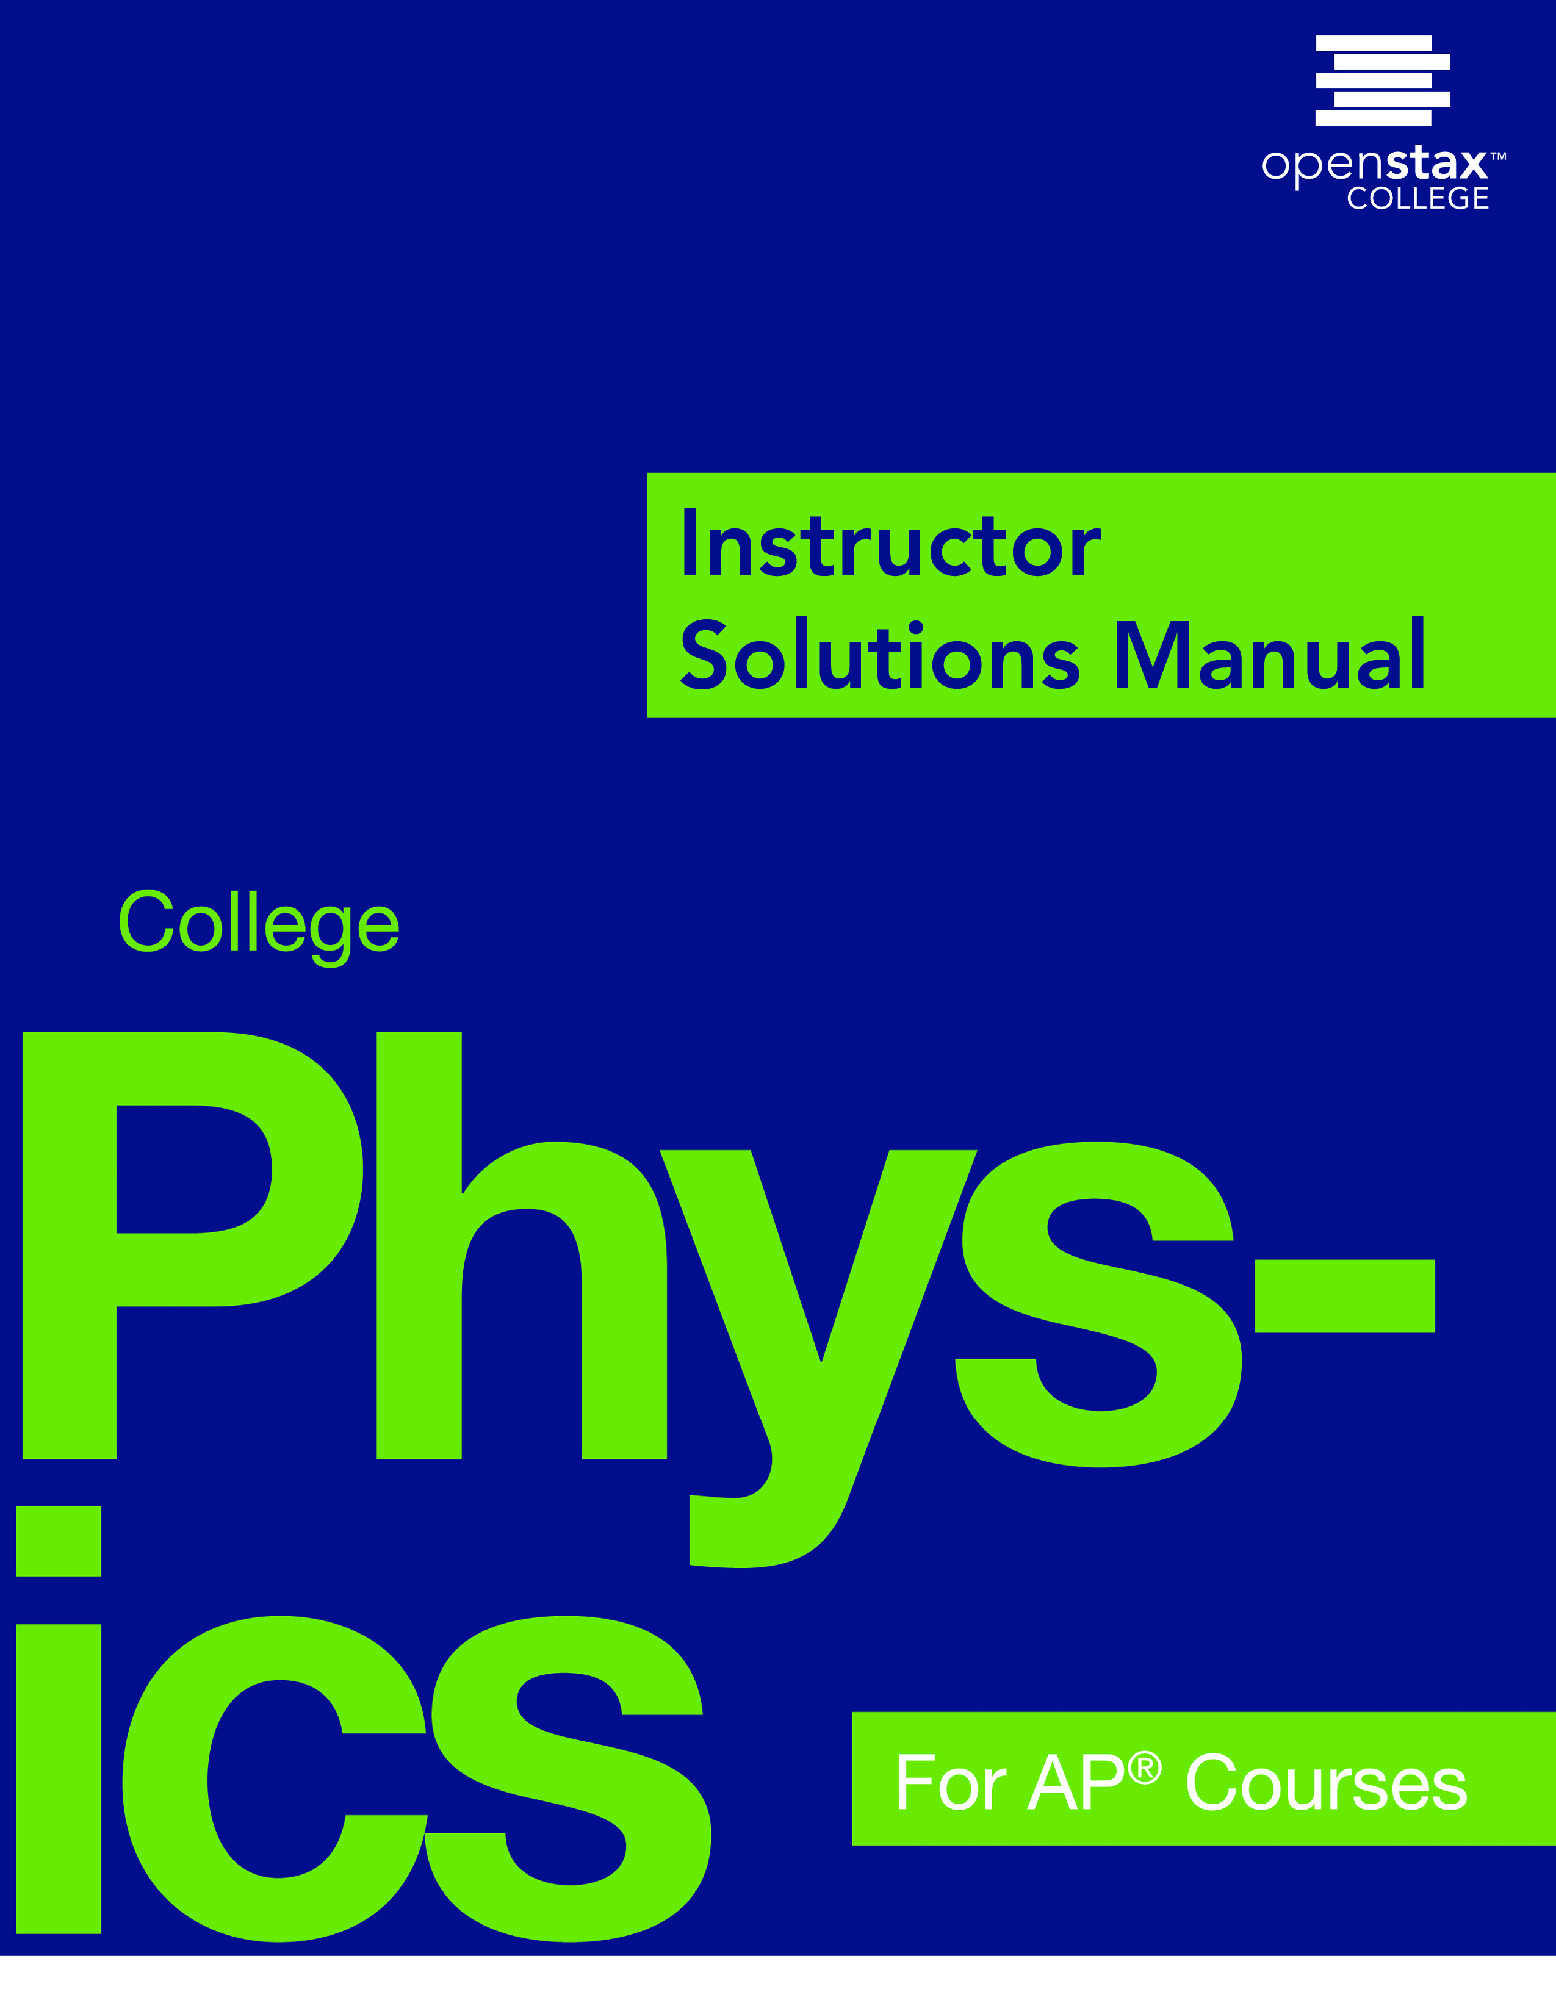Chapter 1: INTRODUCTION: THE NATURE OF SCIENCE AND PHYSICS

**1.2 Physical Quantities and Units**

|  |  |
| --- | --- |
| 1. | *The speed limit on some interstate highways is roughly 100 km/h. (a) What is this in meters per second? (b) How many miles per hour is this?* |
| Solution | (a)  (b) |
| 2. | *A car is traveling at a speed of* *. (a) What is its speed in kilometers per hour? (b) Is it exceeding the*  *speed limit?* |
| Solution | (a)  (b) At 120 km/h, the car is travelling faster than the speed limit. |
| 3. | *Show that . Hint: Show the explicit steps involved in converting .* |
| Solution |  |
| 4. | *American football is played on a 100-yd-long field, excluding the end zones. How long is the field in meters? (Assume that 1 meter equals 3.281 feet.)* |
| Solution |  |
| 5. | *Soccer fields vary in size. A large soccer field is 115 m long and 85 m wide. What are its dimensions in feet and inches? (Assume that 1 meter equals 3.281 feet.)* |
| Solution |  |
| 6. | *What is the height in meters of a person who is 6 ft 1.0 in. tall? (Assume that 1 meter equals 39.37 in.)* |
| Solution | ; |
| 7. | *Mount Everest, at 29,028 feet, is the tallest mountain on the Earth. What is its height in kilometers? (Assume that 1 kilometer equals 3,281 feet.)* |
| Solution |  |
| 8. | *The speed of sound is measured to be  on a certain day. What is this in km/h?* |
| Solution |  |
| 9. | *Tectonic plates are large segments of the Earth’s crust that move slowly. Suppose that one such plate has an average speed of 4.0 cm/year. (a) What distance does it move in 1.0 s at this speed? (b) What is its speed in kilometers per million years?* |
| Solution | (a)  (b) |
| 10. | *(a) Refer to Table 1.3 to determine the average distance between the Earth and the Sun. Then calculate the average speed of the Earth in its orbit in kilometers per second. (b) What is this in meters per second?* |
| Solution | (a)  (b) |

**1.3 Accuracy, Precision, and Significant Figures**

|  |  |
| --- | --- |
| 11. | *Suppose that your bathroom scale reads your mass as 65 kg with a  uncertainty. What is the uncertainty in your mass (in kilograms)?* |
| Solution |  |
| 12. | *A good-quality measuring tape can be off by 0.50 cm over a distance of 20 m. What is its percent uncertainty?* |
| Solution |  |
| 13. | *(a) A car speedometer has a*  *uncertainty. What is the range of possible speeds when it reads* *? (b) Convert this range to miles per hour.* |
| Solution | (a)  (b) |
| 14. | *An infant’s pulse rate is measured to be*  *beats/min. What is the percent uncertainty in this measurement?* |
| Solution |  |
| 15. | *(a) Suppose that a person has an average heart rate of 72.0 beats/min. How many beats does he or she have in 2.0 y? (b) In 2.00 y? (c) In 2.000 y?* |
| Solution | (a)  (limited by 2.0 y)  (b)  (limited by 2.00 y)  (c)  (limited by 72.0 beats/min) |
| 16. | *A can contains 375 mL of soda. How much is left after 308 mL is removed?* |
| Solution | (uncertainty in the 1’s column) |
| 17. | *State how many significant figures are proper in the results of the following calculations: (a)  (b) (c) .* |
| Solution | (a) 3 (limited by 98.2 and 1.01)  (b) 3 (limited by 18.7)  (c) 3 (limited by 1.60) |
| 18. | *(a) How many significant figures are in the numbers 99 and 100? (b) If the uncertainty in each number is 1, what is the percent uncertainty in each? (c) Which is a more meaningful way to express the accuracy of these two numbers, significant figures or percent uncertainties?* |
| Solution | (a) 99 has 2 sig. figs. ; 100 has 3 sig. figs. at most  (b) ;  (if all zeros are significant)  (c) percent uncertainties |
| 19. | *(a) If your speedometer has an uncertainty of*  *at a speed of* *, what is the percent uncertainty? (b) If it has the same percent uncertainty when it reads* *, what is the range of speeds you could be going?* |
| Solution | (a)  (b)  So the range is  or |
| 20. | *(a) A person’s blood pressure is measured to be . What is its percent uncertainty? (b) Assuming the same percent uncertainty, what is the uncertainty in a blood pressure measurement of ?* |
| Solution | (a)  (b) |
| 21. | *A person measures his or her heart rate by counting the number of beats in* *. If*  *beats are counted in* *, what is the heart rate and its uncertainty in beats per minute?* |
| Solution | The heart rate is |
| 22. | *What is the area of a circle*  *in diameter?* |
| Solution |  |
| 23. | *If a marathon runner averages 9.5 mi/h, how long does it take him or her to run a 26.22-mi marathon?* |
| Solution |  |
| 24. | *A marathon runner completes a*  *course in 2 h, 30 min, and 12 s. There is an uncertainty of  in the distance traveled and an uncertainty of 1 s in the elapsed time. (a) Calculate the percent uncertainty in the distance. (b) Calculate the uncertainty in the elapsed time. (c) What is the average speed in meters per second? (d) What is the uncertainty in the average speed?* |
| Solution | (a)  (b)  (c)  (d) |
| 25. | *The sides of a small rectangular box are measured to be* *,* *, and*  *long. Calculate its volume and uncertainty in cubic centimeters.* |
| Solution | Use the methods of adding percents.    Adding these values and rounding to 1 sig. fig., the percent uncertainty of the volume is 5%. The volume is thus |
| 26. | *When non-metric units were used in the United Kingdom, a unit of mass called the* pound-mass *(lbm) was employed, where . (a) If there is an uncertainty of  in the pound-mass unit, what is its percent uncertainty? (b) Based on that percent uncertainty, what mass in pound-mass has an uncertainty of 1 kg when converted to kilograms?* |
| Solution | (a)  (b) |
| 27. | *The length and width of a rectangular room are measured to be*  *and* *. Calculate the area of the room and its uncertainty in square meters.* |
| Solution | The area is . Now use method of adding percents to get uncertainty in the area.      So the area is |
| 28. | *A car engine moves a piston with a circular cross section of  diameter a distance of  to compress the gas in the cylinder. (a) By what amount is the gas decreased in volume in cubic centimeters? (b) Find the uncertainty in this volume.* |
| Solution | (a)  (b) Now use method of adding percents to get uncertainty in the volume. |

**1.4 Approximation**

|  |  |
| --- | --- |
| 29. | *How many heartbeats are there in a lifetime?* |
| Solution |  |
| 30. | *A generation is about one-third of a lifetime. Approximately how many generations have passed since the year 0 AD?* |
| Solution |  |
| 31. | *How many times longer than the mean life of an extremely unstable atomic nucleus is the lifetime of a human? (Hint: The lifetime of an unstable atomic nucleus is on the order of .)* |
| Solution |  |
| 32. | *Calculate the approximate number of atoms in a bacterium. Assume that the average mass of an atom in the bacterium is ten times the mass of a hydrogen atom. (Hint: The mass of a hydrogen atom is on the order of  and the mass of a bacterium is on the order of .)* |
| Solution |  |
| 33. | *Approximately how many atoms thick is a cell membrane, assuming all atoms there average about twice the size of a hydrogen atom?* |
| Solution |  |
| 34. | *(a) What fraction of Earth’s diameter is the greatest ocean depth? (b) The greatest mountain height?* |
| Solution | (a)  (b) Take the highest mountain to be roughly 104 m. Then, |
| 35. | *(a) Calculate the number of cells in a hummingbird assuming the mass of an average cell is ten times the mass of a bacterium. (b) Making the same assumption, how many cells are there in a human?* |
| Solution | (a)  (b) |
| 36. | *Assuming one nerve impulse must end before another can begin, what is the maximum firing rate of a nerve in impulses per second?* |
| Solution |  |

This file is copyright 2015, Rice University. All Rights Reserved.